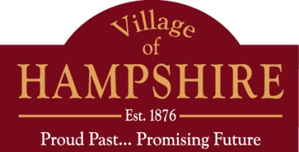Village of Hampshire

Village Board Meeting

Thursday August 21, 2014 – 7:00 PM

Hampshire Village Hall – 234 S. State Street

AGENDA

1. Call to Order
2. Establish Quorum (Physical and Electronic)
3. Pledge of Allegiance
4. Citizen Comments
5. Approval of Minutes –August 7, 2014
6. Village President’s Report
   1. Application for Raffle License – St. Charles Borromeo
   2. Champion Paving proposal: Memorial Park
   3. Women’s Service League Glo Run-September 20, 2014 at 7 p.m. Starts from St. Charles Borromeo to Jefferson-White Oak to Johnson. Barricades for road closures will be set up.
   4. Block Party Sunday August 31 from 3-9 p.m.- White Oak to Panama to Pre –School Drive

7) Village Board Committee Reports

a) Economic Development

b) Finance

1. Accounts Payable

2. Personnel Handbook

c) Planning/Zoning

d) Public Safety

1. Public Works
2. Village Services
3. Fields & Trails
4. New Business
5. Announcements
6. Executive Session: Personnel- appointment, employment, compensation, discipline, performance or dismissal of a specific employee under Section 2 (c )1 and Probable, Pending or Imminent Litigation under Section 2(c) (11)
7. Any items to be reported and acted upon by the Village Board after returning to open session
8. Adjournment